

Student Name | <<enter Full Name >>
SRN No | <<enter SRN No >>
Roll No | <<Enter Roll No>>
Program | <<AIDS / Computer Engg.>>
Year | Third Year
Division | <<Enter division>>
Subject | Computer Network Laboratory (BTECCE21506)
Assignment No | One

Assignment Number - 02

Title : Study of Linux and Windows Network commands

Problem Statement Studying Linux and Windows network commands. [ ping, pathping, ipconfig/ifconfig, arp, netstat, nbtstat, nslookup, route, traceroute/tracert, nmap, etc]

Try to execute following commands on linux terminal or Windows command prompt.
  - ipconfig / ifconfig
  - ping
  - Tracert/Traceroute/Tracepath
  - NSlookup
  - Netstat
  - Hostname
  - Port Scan / nmap
  - Arp Route
  - Whois
- Write description of each command and take snapshot of execution of command through terminal / command prompt and add after command description.

Theory :

- Ipconfig – try to run with ipconfig-all
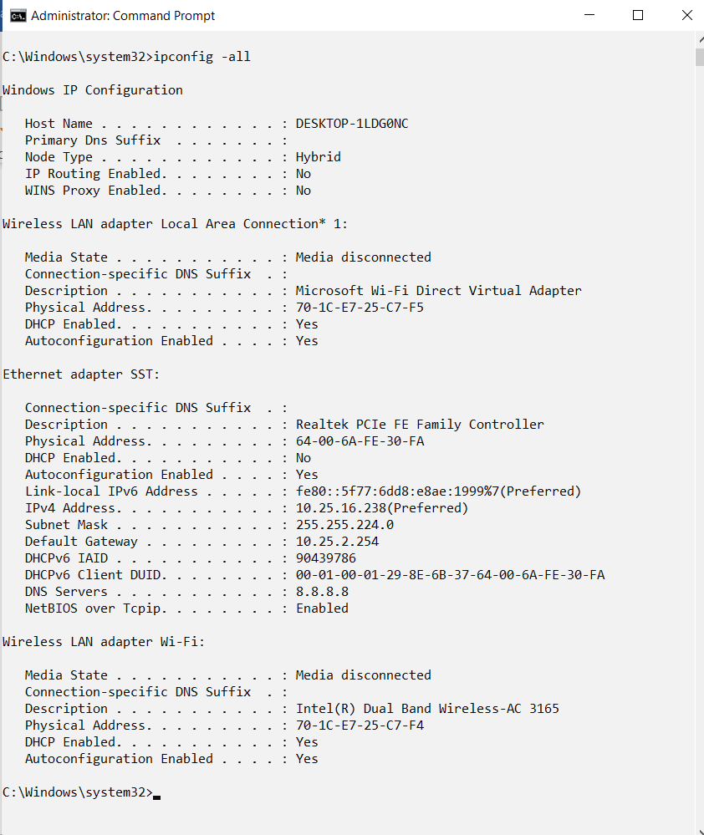

- Ping
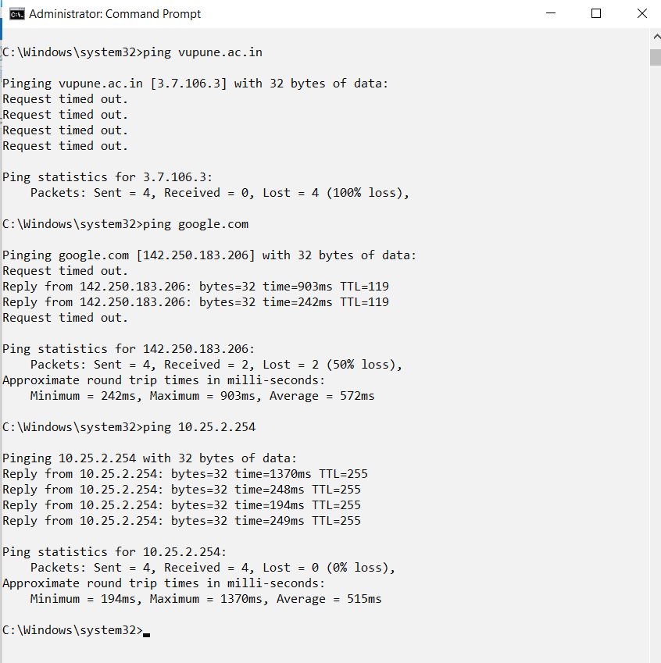

- Tracert /traceroute
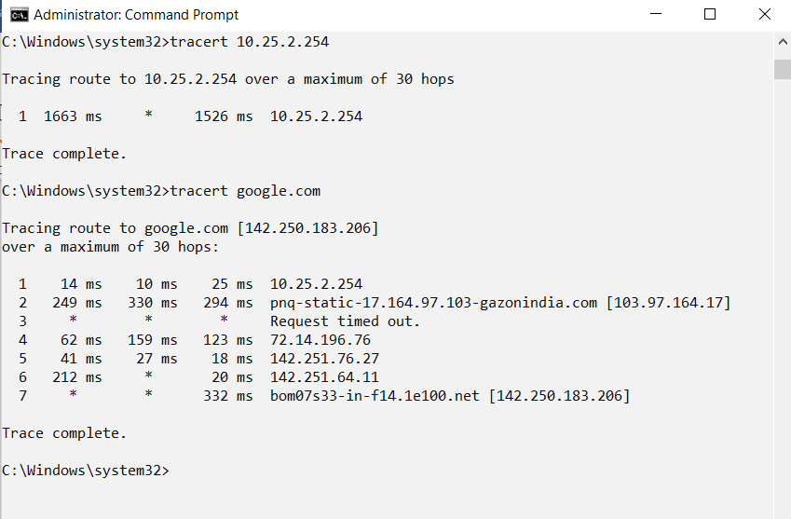

- Hostname
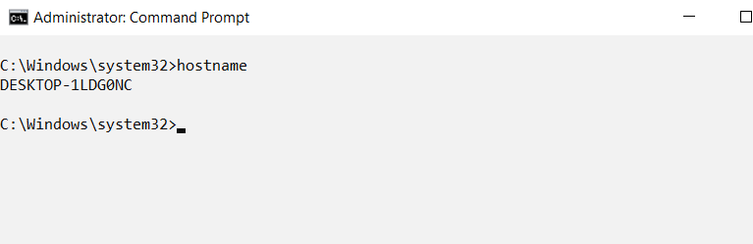

- Nslookup
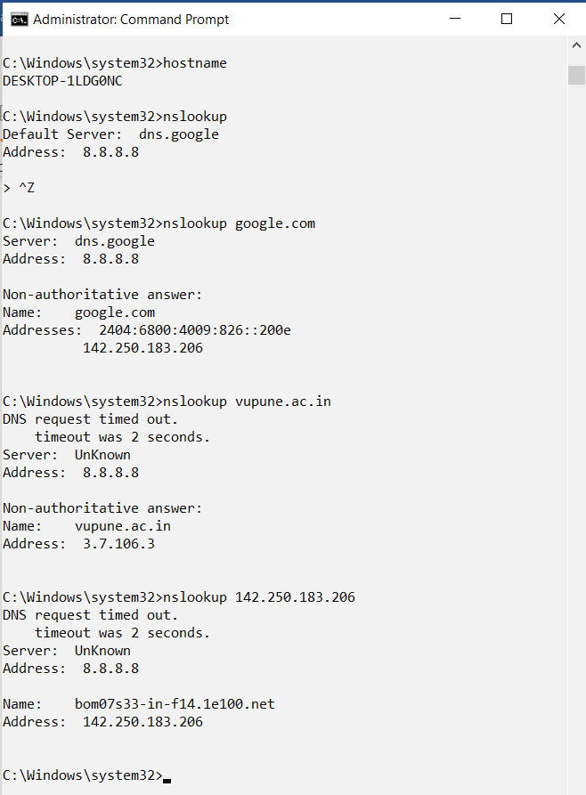

- Arp
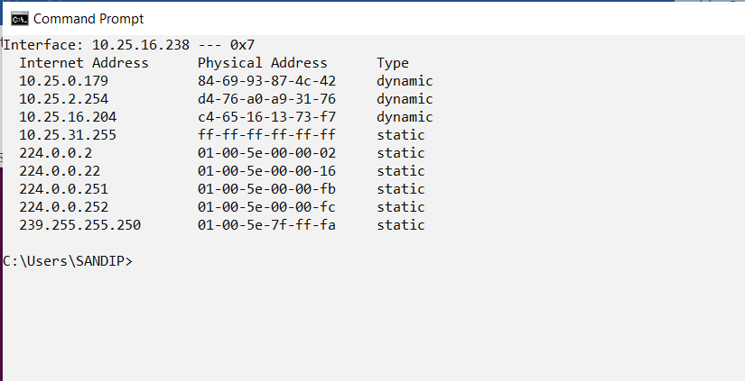
Conclusion : <<Write Conclusion in your own words. Write about what you learn from assignment>>

